**SECTION A**

**Attempt** any three **questions**

1. Describe briefly how chlorine is manufactured from brine. (05 marks)
2. Write equations to show how chlorine reacts with: (04½ marks)
3. Water exposed highly to sunlight.
4. Dilute sodium hydroxide solution.
5. Sodium sulphite solution.
6. The table below shows the hydrides of group (VII) elements and their boiling points.

|  |  |  |  |  |
| --- | --- | --- | --- | --- |
| Hydrides | HF | HCl | HBr | HI |
| Boiling point/ᵒC | +20 | -85 | -67 | -35 |
| Period numbers | 2 | 3 | 4 | 5 |

1. Plot a graph of boiling points against period number. (04½ marks)
2. Explain the graph’s shape. (05 marks)
3. Explain the trend in the acidic strength of the hydrides. (02 marks)
4. The vapour pressures of pure ethanol at **70ᵒC** are **400mmHg** and **1,400mmHg** respectively. The vapour pressure of the mixture at the same temperature is **760mmHg**.
5. Calculate the composition of the liquid mixture at the same temperature. (03½ marks)
6. A mixture of benzene and toluene behaves as an ideal solution. Calculate the composition of the vapour obtained:
7. From a liquid mixture containing **0.6 mole** fraction of benzene. (02½ marks)
8. When the vapour in (b) (i) above is condensed and revaporized. (02½ marks)
9. The boiling point of water is **100ᵒC** and an alcohol Y is **80ᵒC**. A mixture of the two liquids when boiled gives a constant boiling mixture at **78ᵒC** containing **95%** of water.
10. Define the term constant boiling point mixture. (01 mark)
11. Using a well labeled diagram, Describe what would happen if a mixture containing less than **95%** water was fractionally distilled. (05½ marks)
12. Define the term Eutectic mixture. (01 mark)
13. Bismuth and cadmium form a liquid at **300**. Describe what happens when the concentration of bismuth in the mixture is increased. (01½ marks)
14. Determine the mass of bismuth that crystallizes when **200g** of the mixture containing **25%** cadmium was cooled from **300** to **168** at **38%** cadmium. (02½ marks)
15. A sweet smelling organic compound, W has a molecular formula, **C8H8O2** and it burns with a sooty flame.
16. Write structure formulae and IUPAC names of organic compound, W. (02 marks)
17. When organic compound, W was warmed with dilute sulphuric acid, Compound, X **C6H6O** and Y **C2H4O2**were formed. A calcium salt of compound, Y on strong heating yields compound, Z which formed a white crystalline solid on treatment with an acidified solution of sodium sulphite. Identify organic compound, W and write equations leading to the formation of X and Z. (03 marks)
18. Write the equation and suggest a mechanism for the reaction between: (@05 marks)
19. X with hot fuming sulphuric acid.
20. Z with acidified hydrazine.
21. Comparing X and 2, 4, 6-trinitrophenol, name a reagent that can be used to:
22. Identify the major functional group.
23. Distinguish between the two compounds.

[In each case state what is observed if the named reagent is treated separately with the organic compounds] (05 marks)

1. **0.0627g** of an organic compound, Y on complete combustion yielded **0.036g** of water. In another experiment, **0.0209g** of the same compound yielded **29.88cm3** of carbon dioxide gas measured at standard conditions of temperature.
2. Calculate the empirical formula of an organic compound, Y. (06 marks)
3. An organic compound, Y in (a) above was steam distilled at a temperature of **98ᵒC** and a pressure of **760mmHg**, The distillate was found to contained **72.1%** of water. The vapour pressure of water at the same temperature is **707mmHg**.
4. Deduce the molecular formula of organic compound, Y. (03½ marks)
5. An organic compound, Y burns with a sooty flame. Write the possible structure of organic compound, Y. (01 mark)
6. Write equation and suggest a mechanism for the reaction when bromomethane is added to an alkaline solution of an organic compound, Y. (02½ marks)
7. **3.0g** of zinc ore was dissolved in excess hydrochloric acid. To the products was added excess concentrated ammonia and the solution was then made up to **500.0cm3** of water. The resultant mixture was shaken with tetrachloromethane and left to stand. **25.0cm3** of the organic layer required **12.5cm3** of **0.025M** hydrochloric acid for complete neutralization. **12.5cm3** of the aqueous layer was neutralized by **20.0cm3** of **0.25M** hydrochloric acid. Calculate the percentage purity of the zinc ore. [Partition coefficient of ammonia between tetrachloromethane and water = **0.04**] (07 marks)

**SECTION b**

**Attempt** only two **questions in this section.**

1. The elements carbon, silicon, tin & lead are in group (IV) of the periodic table.
2. Explain the trend in: (@02 marks)
3. Metallic character.
4. Stability of the **+2** oxidation state.
5. Describe the reactions of the group (IV) elements with:
6. Bromine.
7. Concentrated sulphuric acid. (06½ marks)
8. Excess chlorine water was warmed with lead (II) nitrate solution.
9. State what was observed and write the equation for the reaction. (02 marks)
10. The mixture from (c) (i) was filtered and the residue warmed with concentrated hydrochloric acid. State what was observed and explain your answer. (05 marks)
11. To a portion of the filtrate from (c) (i) was added drops of aqueous potassium iodide solution followed by carbon tetrachloride. State what was observed and write the equation for the reaction. (02½ marks)
12. (a) (i).Define the term enthalpy of solution. (01 mark)

(ii).Describe two energy factors that affect the enthalpy of solution. (03 marks)

1. **5.35g** of ammonium chloride were added to **100cm3** of water in a plastic beaker and the mixture stirred gently with a thermometer. The temperature of the mixture was recorded at different intervals of time as shown below.

|  |  |  |  |  |  |  |  |  |
| --- | --- | --- | --- | --- | --- | --- | --- | --- |
| Time (s) | 0 | 10 | 20 | 30 | 40 | 50 | 60 | 70 |
| Temperature e/ᵒC | 21.0 | 19.2 | 18.0 | 17.4 | 17.5 | 17.5 | 18.4 | 19.0 |

1. Plot a graph of temperature against time. (03 marks)
2. Use your graph to determine the molar enthalpy of solution of ammonium chloride. State assumption made. (06 marks)

[𝝆water = **1.0g/cm3**, SHC of solution = **4.2J/g/k**]

1. State the effect of increasing temperature on the solubility of ammonium chloride. Give a reason for your answer. (03 marks)
2. Define the term cryoscopic constant.
3. In how much water should **10.7g** of ammonium chloride be dissolved to obtain a solution with a freezing point at a temperature of**-0.465ᵒC**? [Kf for water = **1.86ᵒC/Kg/mol**] (03 marks)
4. Write equations to show how the following compounds can be synthesized.



1. Explain the following observations.
2. Lead (IV) oxide dissolves in concentrated hydrochloric acid to give a yellow solution from which a yellow solid can be separated on addition of a saturated solution of ammonium chloride. (04½ marks)
3. Boron trichloride and phosphorous trichloride have different shapes. (03 marks)
4. Alkenes undergo electrophilic addition reactions whereas carbonyl compounds undergo nucleophilic addition reactions. (04 marks)
5. The freezing point of a solution of **0.02M** ethanoic acid in benzene is higher than that of **0.02M** glucose in the same solvent. (04 marks)
6. Butan-1-ol when dehydrated by concentrated sulphuric acid at **170ᵒC** forms but-2-ene as the major product but not but-1-ene. (04½ marks)

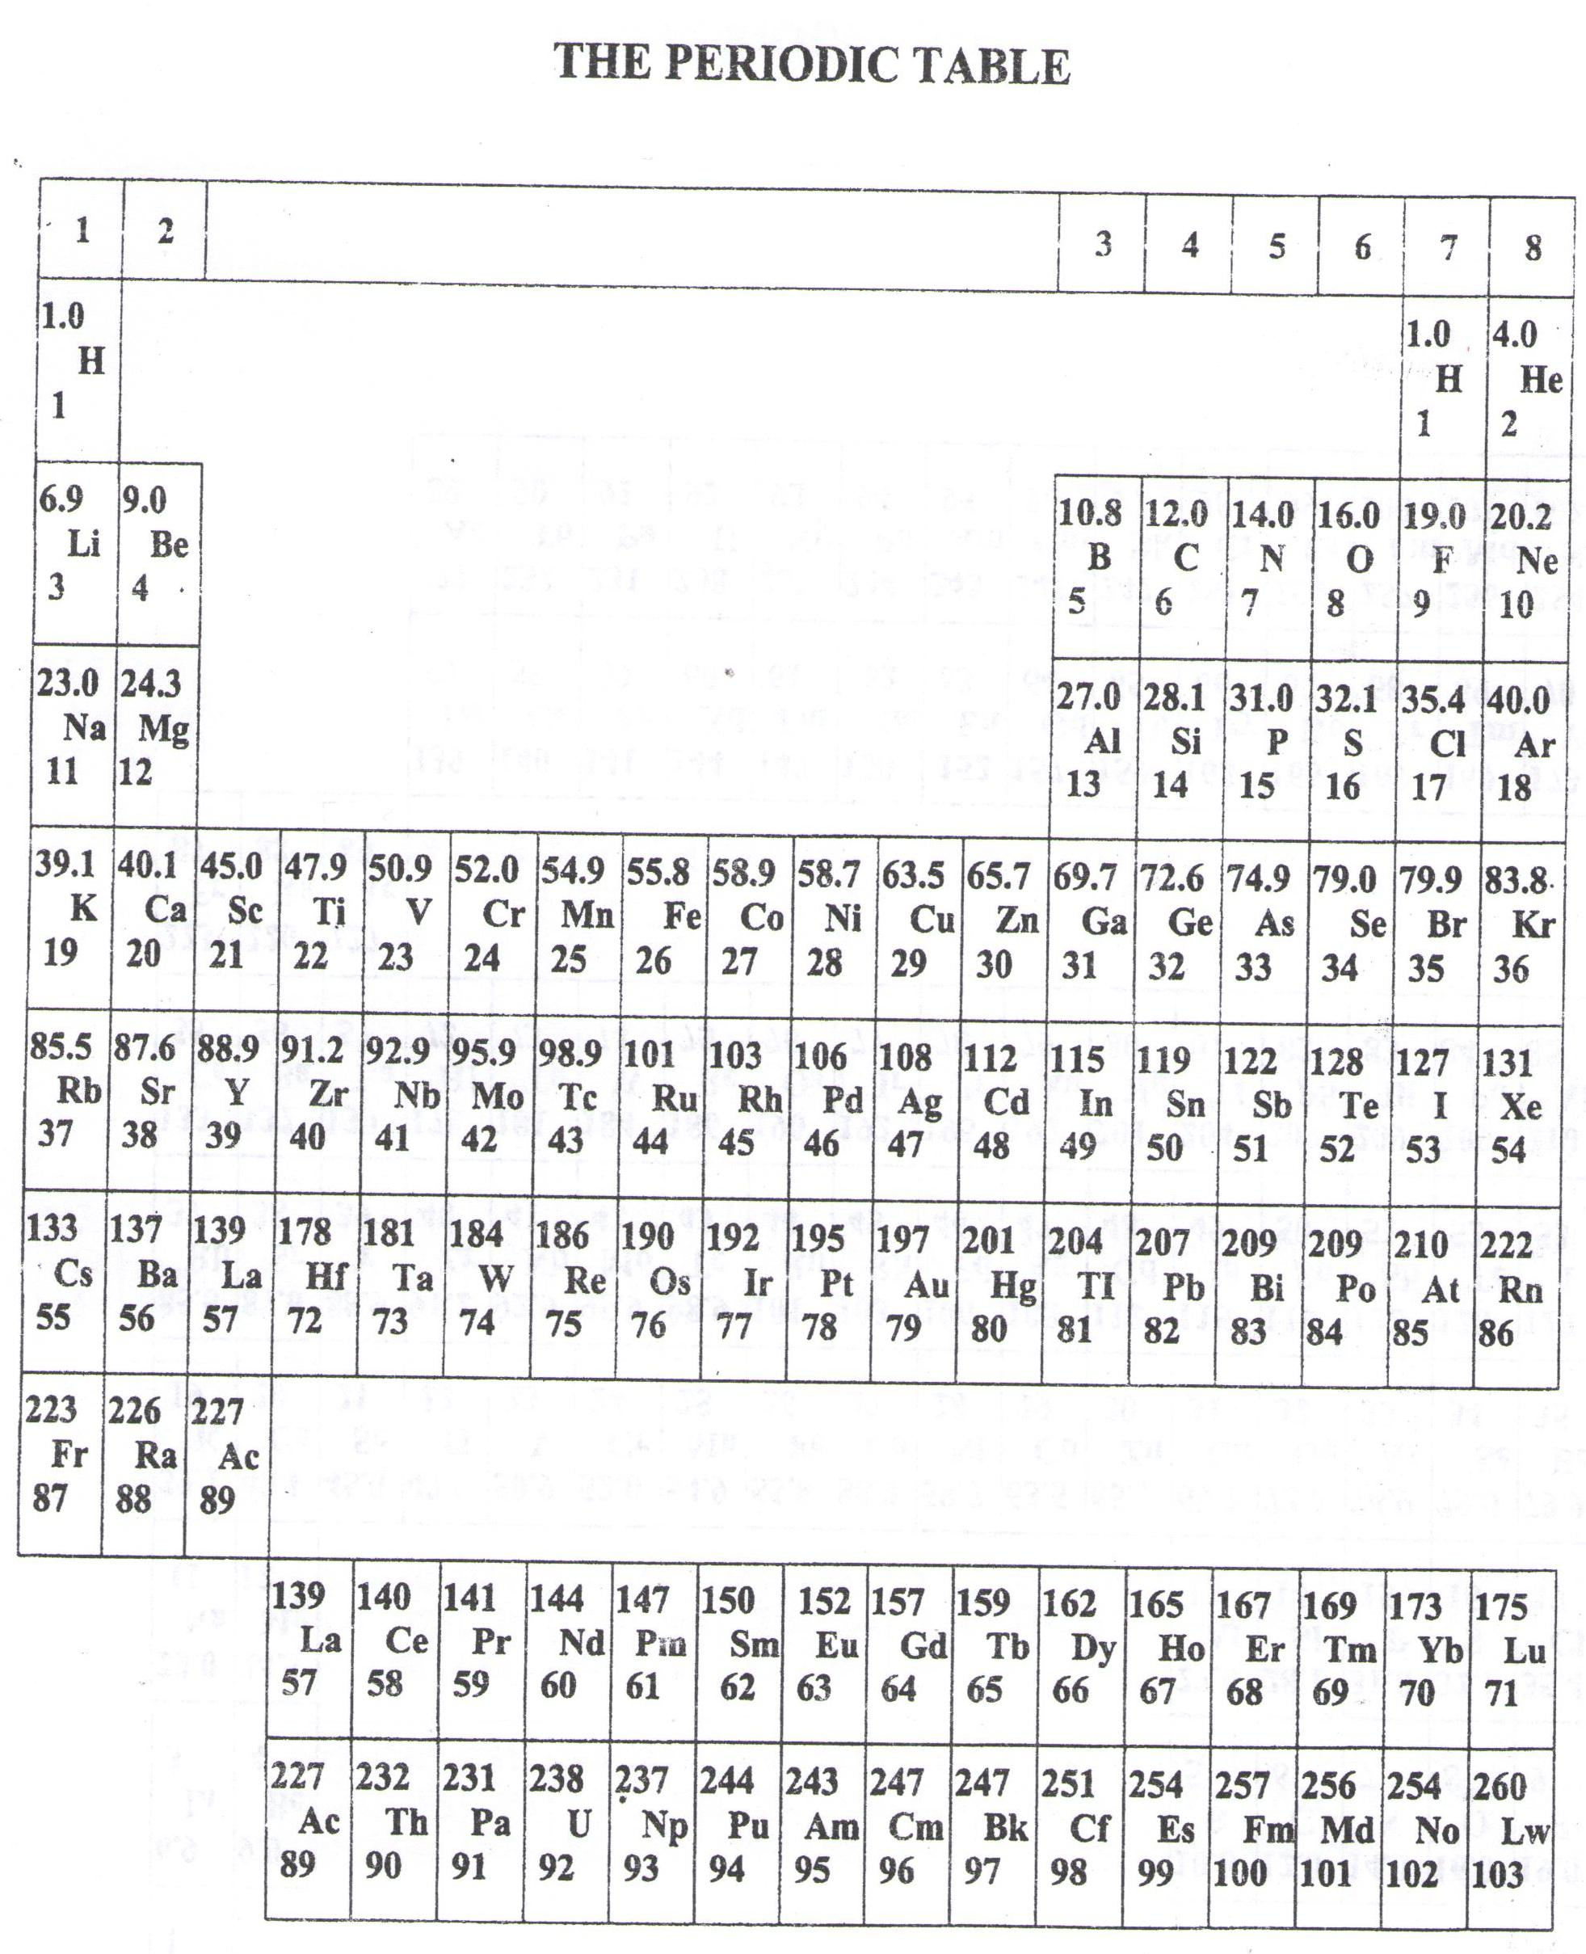

* ===END===

WELCOME TO SENIOR SIX, YEAR 2023

This is the last page of the printed paper, Page 07